|  |  |  |
| --- | --- | --- |
| Department: | |  |
| Approved by | Checked by | Prepared by |
|  |  |  |

Standardized

Version 01

Amendment history

|  |  |  |  |  |  |
| --- | --- | --- | --- | --- | --- |
| Version | Date of preparation | Revision details  (Changed part, changes, affected related documents) | Prepared by | Checked by | Approved by |
| 01 | 2018/10/04 | First version |  |  |  |
|  |  |  |  |  |  |
|  |  |  |  |  |  |
|  |  |  |  |  |  |

Table of Contents

1. Objective 4

2. Scope 4

3. Definitions/References 4

3.1. Definitions 4

4. Outline of software architecture 5

5. Definition of software components 6

5.1. Component list 6

6. Applications layer 7

6.1. GUI package 7

6.2. Application framework 7

7. Middleware layer 8

7.1. Measurement functions 8

7.2. Data I/O 9

7.3. Configurations 10

7.4. GUI framework 10

8. Driver layer 11

8.1. Motor package 11

8.2. Camera package 12

8.3. Light source package 12

8.4. Detector package 13

8.5. Printer package 13

8.6. Storage package 13

8.7. Display package 14

8.8. Communication package 14

8.9. Input package 14

9. Interface definition of software items 15

9.1. Structure of software items 15

9.2. Interrelationship between software items 17

# Objective

The present document is a documented form of the standardized software architecture design specification defined by the Standardization Project (hereinafter referred to as STD Pj). An objective of STD Pj is to define software components necessary for providing key products and specify related interfaces, thus enhancing quality and development efficiency via building and reuse of software assets for the purpose of promoting standardization of eye-care product software.

# Scope

The document applies to software development of the following product series:

* OCT series (excluding Victoria)
* TRC series
* RM/KR series
* CT series
* SP series
* Subjective system/Lens meter (Chronos)

# Definitions/References

## Definitions

| Term/Abbreviation | Description |
| --- | --- |
| Application | A general term for software used to perform specific work. |
| Middleware | A set of general-purpose (common) functions of application software. When application software issues a request to middleware, the middleware issues a necessary request to the driver layer and returns the result to the application software. |
| Driver | Communicates generally via a bus or a communication subsystem with a peripheral device connected to the same. When a program calls a routine in a driver, the driver issues a command to the peripheral device. When the peripheral device returns data to the driver, the driver takes action, for example, calls a routine in the calling program. The driver depends on hardware and differs from OS to OS. |
| Component | A component is software modularized to provide a function.  A component refers to a reusable software component equipped with a definite interface and takes full advantage of the concepts including divide and conquer, separation of concerns, and providing a single function by using a set object. |
| Package | A package is used to group a set of components or classes on the basis of a specific standard. Dependence relationship or call relationship may be represented between packages. A package is used to visualize the software structure and enhance the intelligibility. |

# Outline of software architecture

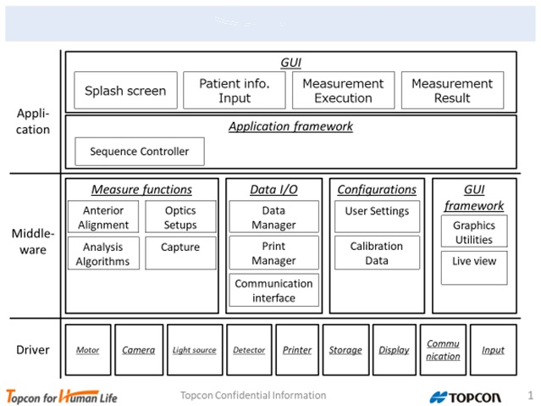

**Software stack view**

# Definition of software components

## Component list

|  |  |  |  |
| --- | --- | --- | --- |
| Layer | Component/Package | | Outline |
| Application | GUI | | Displays a screen. |
| Accepts a user input. |
| Controls a screen transition. |
| Calls a function/sequence necessary for operation of a device. |
| Application framework | | Provides a model for generating a photography/measurement sequence specific to a device. |
| Provides a particular sequence generated with a model. |
| Middleware | Measurement functions | Anterior alignment | Executes anterior ocular area alignment. |
| Optics setups | Aligns an optical system focus with a measurement target. |
| Capture | Executes measurement. |
| Analysis | Calculates a measurement result. |
| Data I/O | Data manager | Retains patient information. |
| Retains a measurement result. |
| Print manager | Generates a print image. |
| Communication interface | Accepts data from an external device. |
| Generates external output data. |
| Configurations | User settings | Retains user setting. |
| Reads/Writes user setting from/to a storage. |
| Correction data | Retains a correction value (necessary for operation of a device). |
| Reads/Writes a correction value from/to a storage. |
| GUI framework | GUI backend | Provides GUI parts necessary for screen display. |
| Accepts data from an external input device (connected to a device). |
| Live view | Displays a live image. |
| Driver | Motor | | Controls a motor. |
| Camera | | Acquires an image from a camera. |
| Light source | | Controls a light source. |
| Detector | | Acquires data from a detector. |
| Printer | | Controls a printer. |
| Storage | | Manages a storage. |
| Display | | Controls a display. |
| Communication | | Performs data transmission/reception. |
| Input | | Acquires/Accepts an input. |

# Applications layer

## GUI package

|  |  |  |
| --- | --- | --- |
| Screen name | Outline | Action item |
| Splash screen | Displays the startup screen from when the power is turned on to when the device becomes operative. | Display the startup screen. |
| Start the OS. |
| Initialize the device. |
| Patient info. Input screen | Displays a screen for inputting patient information. | Display patient information. |
| Input patient information. |
| Search for patient information. |
| Save patient information |
| Input/Display patient information. |
| Measurement execution screen | Displays a live image necessary for operation of the device and performs measurement. | Display a patient eye live image. |
| Display the photography/measurement screen. |
| Accept preparatory operation for photography/measurement. |
| Accept start of photography/measurement. |
| Measurement result screen | Displays a photography/measurement result. | Display the measurement result. |
| Display a photographic image. |
| Perform print. |
| Send data to an external device. |
| Setup menu screen | Displays the user setting screen. | Display the setting screen. |
| Call saved setting. |
| Change the setting. |
| Save the setting. |

## Application framework

|  |  |  |
| --- | --- | --- |
| Sub-component name | Outline | Action item |
| Sequence controller | Generates a photography/measurement sequence. | Provide a template for generating a photography/measurement sequence specific to a device. |
| Provide a device specific sequence generated with the template. |

# Middleware layer

## Measurement functions

|  |  |  |  |  |
| --- | --- | --- | --- | --- |
| Sub-component name | Outline | Operation | Input | Output |
| Anterior alignment | Moves the measurement unit to a measurable position. | start | none | complete/failure |
| Optics setups | Aligns a lens focus. | optimizeFocus | none | complete/failure |
| Aligns the azimuth angle of polarization. | optimizePolarization | none | complete/failure |
| Aligns the optical path length with the observation site. | adjustOpticalPathLength | none | complete/failure |
| Aligns the spectrometer unit Y-axis position. | optimizeYLensPositoin | none | complete/failure |
| Adjusts the optical path so as to project light at a specified position on the retina. | XYalignment | x, y | complete/failure |
| Executes fogging. | fogging | none | complete/failure |
| Capture | Acquires an image. | getImage | none | image |
| Analysis | Converts a picture quality into a numeral. | calcImageQuality | image | imageQuality |
| Converts the intensity on the sensor into a numeral. | calcLightIntensity | image | lightIntensity |
| Obtains the cornea vertex position. | calcCornealVertexPosition | image | (x, y, z) |
| Obtains the pupil center coordinates. | calcPupilCenterPosition | image | (x, y, z) |
| Obtains the relative coordinates of an eye from a fundus oculi image. | calcRetinalXYPossition | image, reference image | (dx, dy) |
| Obtains a corneal shape. | calcCornealCurvature | image, z | R1, R2, A1, A2 |
| Obtains an eyeball refractive power. | calcRefractivePower | image | Spherical, Cylinder, Axis |

## Data I/O

|  |  |  |  |  |
| --- | --- | --- | --- | --- |
| Sub-component name | Outline | Operation | Input | Output |
| Data manager | Acquires patient information. | readPatientInfo | none | patientInfo |
| Acquires a photographic image. | readResultImage | none | image |
| Acquires the result of a measured numerical value. | readMeasuredResults | none | measuredResults |
| Saves patient information. | writePatientInfo | patientInfo | none |
| Saves the photographic image. | writeResultImage | resultImage | none |
| Saves the result of the measured numerical value. | writeMeasuredResults | measuredResults | none |
| Print manager | Generates a print image. | createPreviewImage | patientInfo, printFormat, measuredResults | previewImage |
| Performs print. | print | patientinfo, printFormat, measuredResults | print result |
| Communication interface | Acquires patient information and a previous measurement result from a specified server. | findPatientInfoFrom(server) | server, patientID | patientInfo, resultImage, measuredResults |
| Registers patient information and the measurement result to a specified server. | registerPatientInfoTo(server) | server, patientInfo, resultImage, measuredResults | none |
| Acquires a work list from a specified server. | findWorkListFrom(server) | server | work list |
| Outputs a photographic image to an external device. | exportResultImage | none | resultImage |
| Outputs a measurement result to an external device. | exportMeasuredResults | none | measuredResults |

Search function: DICOM server, inquiry to IMAGEnetR4, parsing of inquiry result

## Configurations

|  |  |  |  |  |
| --- | --- | --- | --- | --- |
| Sub-component name | Outline | Operation | Input | Output |
| User settings | Acquires user setting. | readUserSetting | none | userSetting |
| Updates user setting. | updateUserSetting | userSetting | none |
| Correction data | Acquires a correction value. | readCorrectionData | none | correctionData |
| Updates a correction value. | updateCorrectionData | correctionData | none |

## GUI framework

|  |  |  |  |  |
| --- | --- | --- | --- | --- |
| Sub-component name | Outline | Operation | Input | Output |
| GUI backend | Development by using Qt/C++. | Qt base | - | - |
| Development by using WebKit/HTML or JS. | Web base | - | - |
| Live view | Streams a live image. | LiverStreamServer |  |  |

# Driver layer

## Motor package

|  |  |  |  |  |
| --- | --- | --- | --- | --- |
| Driver | Outline | Operation | Input | Output |
| Alignment | Moves the measurement unit to a specified position. | move a measurement unit | position | result |
| Notifies the current position. | current position notice | none | current position |
| Notifies amotor limit. | limit reached notice | none | result |
| Moves a chinrest | move the chinrest | up/down stop | none |
| Focus | Moves the lens to a specified position. | movement of the lens | position | result |
| Notifies the current position of the lens. | current position notice | none | current position |
| Notifies amotor limit. | limit reached notice | none | result |
| Optical path | Switches over a filter in the optical path. | filter switching | filter value | result |
| Switches over the aperture of a lens on the optical path. | aperture switching | aperture value | result |
| Changes the optical path length. | change to optical path length | value | result |
| Switches over a site illuminated by the light source. | switching of measurement unit | value | result |
| Switches over a slit on the optical path. | switching of slit | ON/OFF | result |
| Switches over a correction lens on the optical path. | switching of correction lens | ON/OFF | result |
| Rotates a rotary prism on the optical path. | driving of rotary prism | ON/OFF | result |
| Changes the polarization state via double refraction | polarization control | value | result |
| Adjusts the position on Y-axis of diffracted light. | Y-axis auto | adjustment value | result |
| Air puff | Moves the cylinder and blows an air puff. | air puff execution | ON/OFF | result |
| Galvano | Performs scan pattern setting. | scan pattern setting | set value | result |
| Performs a scan. | scan start | none | result |
| Fixes a scan position. | setting of tracking | ON/OFF | result |

## Camera package

|  |  |  |  |  |
| --- | --- | --- | --- | --- |
| Driver | Outline | Operation | Input | Output |
| Area camera | Starts a series of capture operation. | capture start | ON/OFF | result |
| Acquires a captured area image. | image acquisition | size | image |
| Line camera | Starts a series of capture operation. | capture start | ON/OFF | result |
| Acquires a captured line image. | image acquisition | size | image |
| OCT scan | Starts a series of scanning of a retinal tomogram image. | scan start | ON/OFF | result |
| Acquires a scanned image. | image acquisition | size | image |

## Light source package

|  |  |  |  |  |
| --- | --- | --- | --- | --- |
| Driver | Outline | Operation | Input | Output |
| Alignment | Projects a light source for alignment. | lighting of light source | ON/OFF | result |
| Observation | Projects a light source for observation. | lighting of light source | ON/OFF | result |
| Sets the light quantity of a light source for observation. | light quantity setting | light quantity | result |
| Measure | Projects a light source for measurement. | lighting of light source | ON/OFF | result |
| Sets the light quantity of a light source for measurement. | light quantity setting | light quantity | result |
| Photography | Starts lighting of a light source for photography. | lighting of light source | ON/OFF | result |
| Sets the light quantity of a light source for photography. | light quantity setting | light quantity | result |
| Sets the emission duration of a light source for photography. | emission duration | duration | result |
| Acquires the charging state of a light source for photography. | acquisition of charging state | none | charging state |
| Fixation | Projects the light source for a fixation target. | lighting of light source | ON/OFF | result |
| UI | Projects a light source for a hazard. | lighting of light source | ON/OFF | result |
| Sets the lighting pattern of a light source for a hazard. | lighting pattern setting | pattern | result |

## Detector package

|  |  |  |  |  |
| --- | --- | --- | --- | --- |
| Driver | Outline | Operation | Input | Output |
| Photo Detector | Acquires the intensity of a target light source. | acquisition of light source intensity | none | light source intensity |
| Temperature | Acquires the temperature of a target. | acquisition of temperature | none | temperature |
| Blink Detector | Acquires presence/absence of a blink | acquisition of blink detection information | none | presence/absence of a blink |
| Pressure | Acquires an intraocular pressure. | acquisition of pressure value | none | pressure |
| Right Left | Acquires right/left information of a selected eye. | acquisition of right/left information | none | right/left position |
| Origin | Detects whether a return to the origin position is made. | acquisition of origin information | none | detection result |
| Limit | Detects whether a limit position is exceeded. | acquisition of limit information | none | detection result |

## Printer package

|  |  |  |  |  |
| --- | --- | --- | --- | --- |
| Driver | Outline | Operation | Input | Output |
| External Printer | Performs print setting. | print setting | set value | result |
| Outputs a print image. | print | print image | result |
| Internal Printer | Performs print setting. | print setting | set value | result |
| Outputs a print image. | print | print image | result |

## Storage package

|  |  |  |  |  |
| --- | --- | --- | --- | --- |
| Driver | Outline | Operation | Input | Output |
| USB | Writes data to a USB-connected storage. | data write | data | result |
| Reads data from a USB-connected storage. | data read | buffer, size | data |
| EEPROM | Writes data to an EEPROM. | data write | data | result |
| Reads data from an EEPROM. | data read | buffer, size | data |
| SD | Writes data to an SD. | data write | data | result |
| Reads data from an SD. | data read | buffer, size | data |
| FLASH | Writes data to a flash memory. | data write | data | result |
| Reads data from a flash memory. | data read | buffer, size | data |

## Display package

|  |  |  |  |  |
| --- | --- | --- | --- | --- |
| Driver | Outline | Operation | Input | Output |
| LVDS | Makes setting of display on the display unit. | display setting | set value | result |
| Displays on the display unit. | screen display | display image | none |

## Communication package

|  |  |  |  |  |
| --- | --- | --- | --- | --- |
| Driver | Outline | Operation | Input | Output |
| LAN | Transmits data. | data transmission | data | result |
| Receives data. | data reception | buffer, size | data |
| UART | Transmits data. | data transmission | data | result |
| Receives data. | data reception | buffer, size | data |
| USB | Transmits data. | data transmission | data | result |
| Receives data. | data reception | buffer, size | data |
| CAN | Transmits data. | data transmission | data | result |
| Receives data. | data reception | buffer, size | data |

## Input package

|  |  |  |  |  |
| --- | --- | --- | --- | --- |
| Driver | Outline | Operation | Input | Output |
| Key | Acquires a key-pressed state. | state acquisition | target | state |
| Lever | Acquires the inclination/rotating state of the lever. | state acquisition | target | state |
| USB | Acquires input information from a USB-connected device. | information acquisition | target | Input value |
| Touch Panel | Acquires coordinates and ON/OFF state from the touch panel. | information acquisition | none | coordinates and ON/OFF state |

# 

# Interface definition of software items

## Structure of software items

### Package view

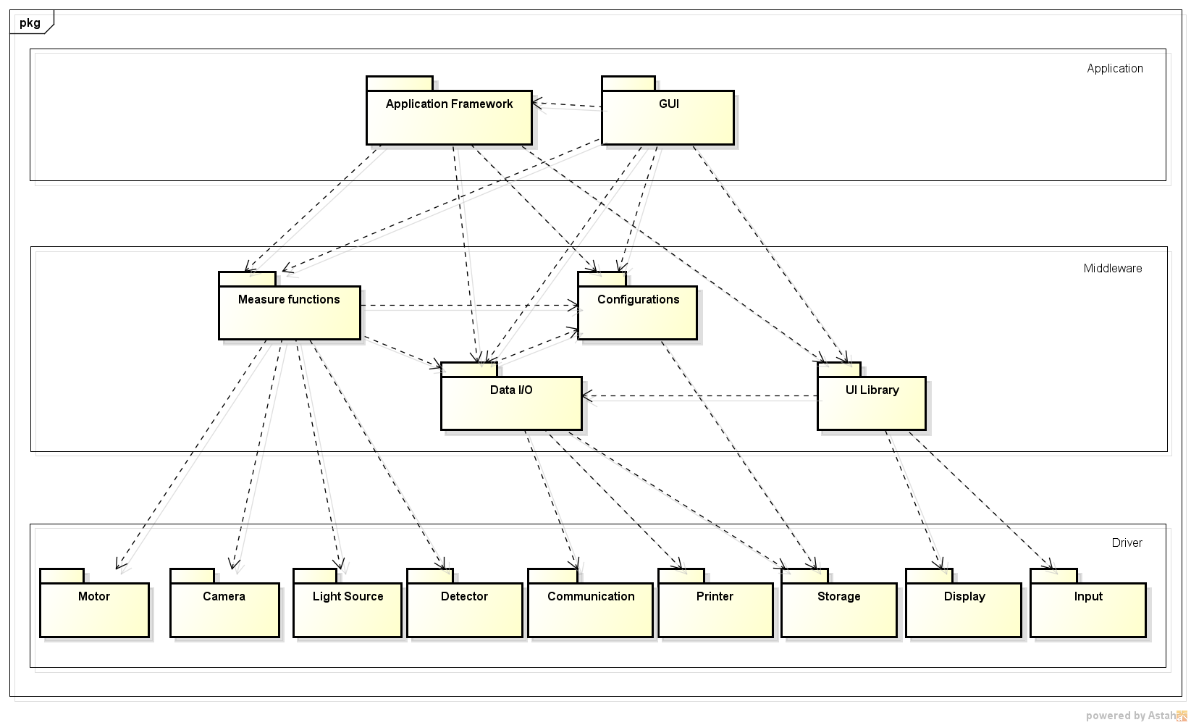

Figure ‑ Package view

### Component layout

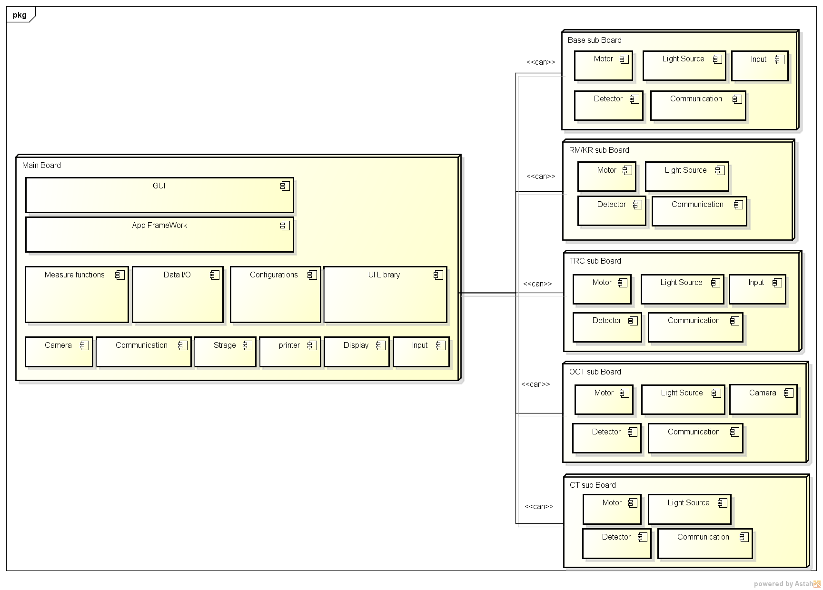

Figure ‑ Component layout

## 

## Interrelationship between software items

### Startup

TBD

### Measurement setting

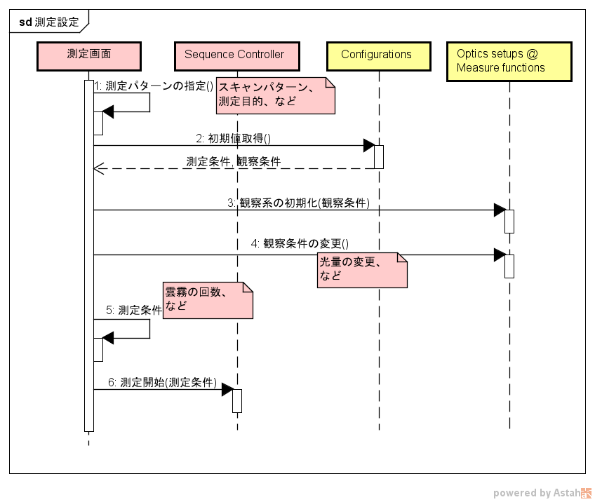

Frequency of clouds

and fog

Start measurement (Measurement conditions)

Changes in Light intensity

5. Measurement   
condition

Changes in observation condition ( )

Initialization of observation system (Observation conditions)

Measurement conditions, observation conditions

Acquire initial value ( )

Scan pattern, purpose of  
 measurement

Specification of measuring pattern ( )

Measurement screen

sd measurement setting

Figure ‑ Measurement setting

### Input of patient information

#### Input of patient information (manual input)

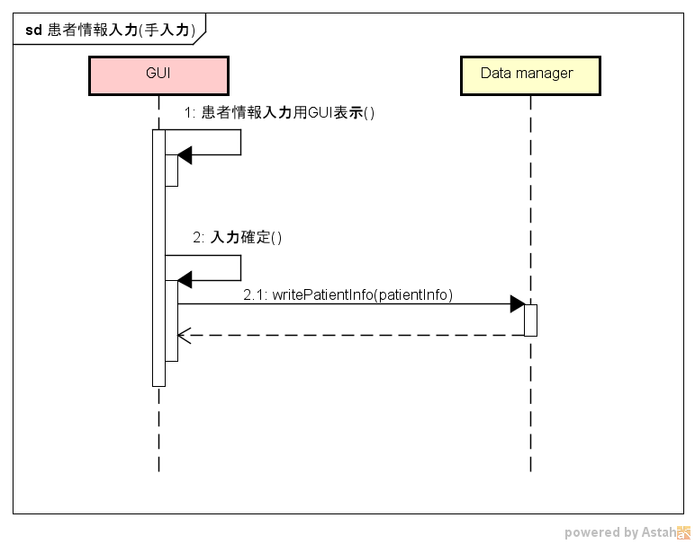

sd Input of patient information (manual input)

GUI Display for patient information input ( )

Fixed input ( )

Figure ‑Input of patient information (manual input)

#### Input of patient information (bar code)

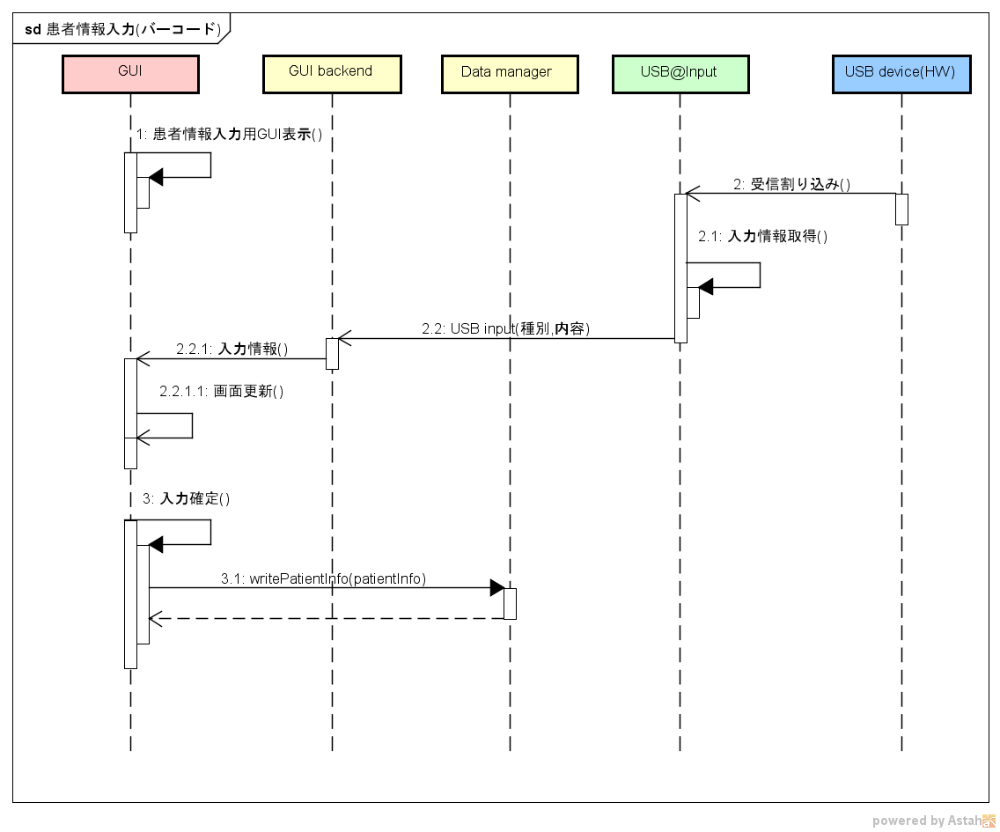

Fixed input ( )

Update screen ( )

USB input (Classification, details)

Acquire input information ( )

Receive interrupt ( )

Input information ()

GUI Display for patient information input ( )

#### sd Input of patient information (bar code)

Figure ‑ Input of patient information (USB input device)

#### Input of patient information (work list selection)

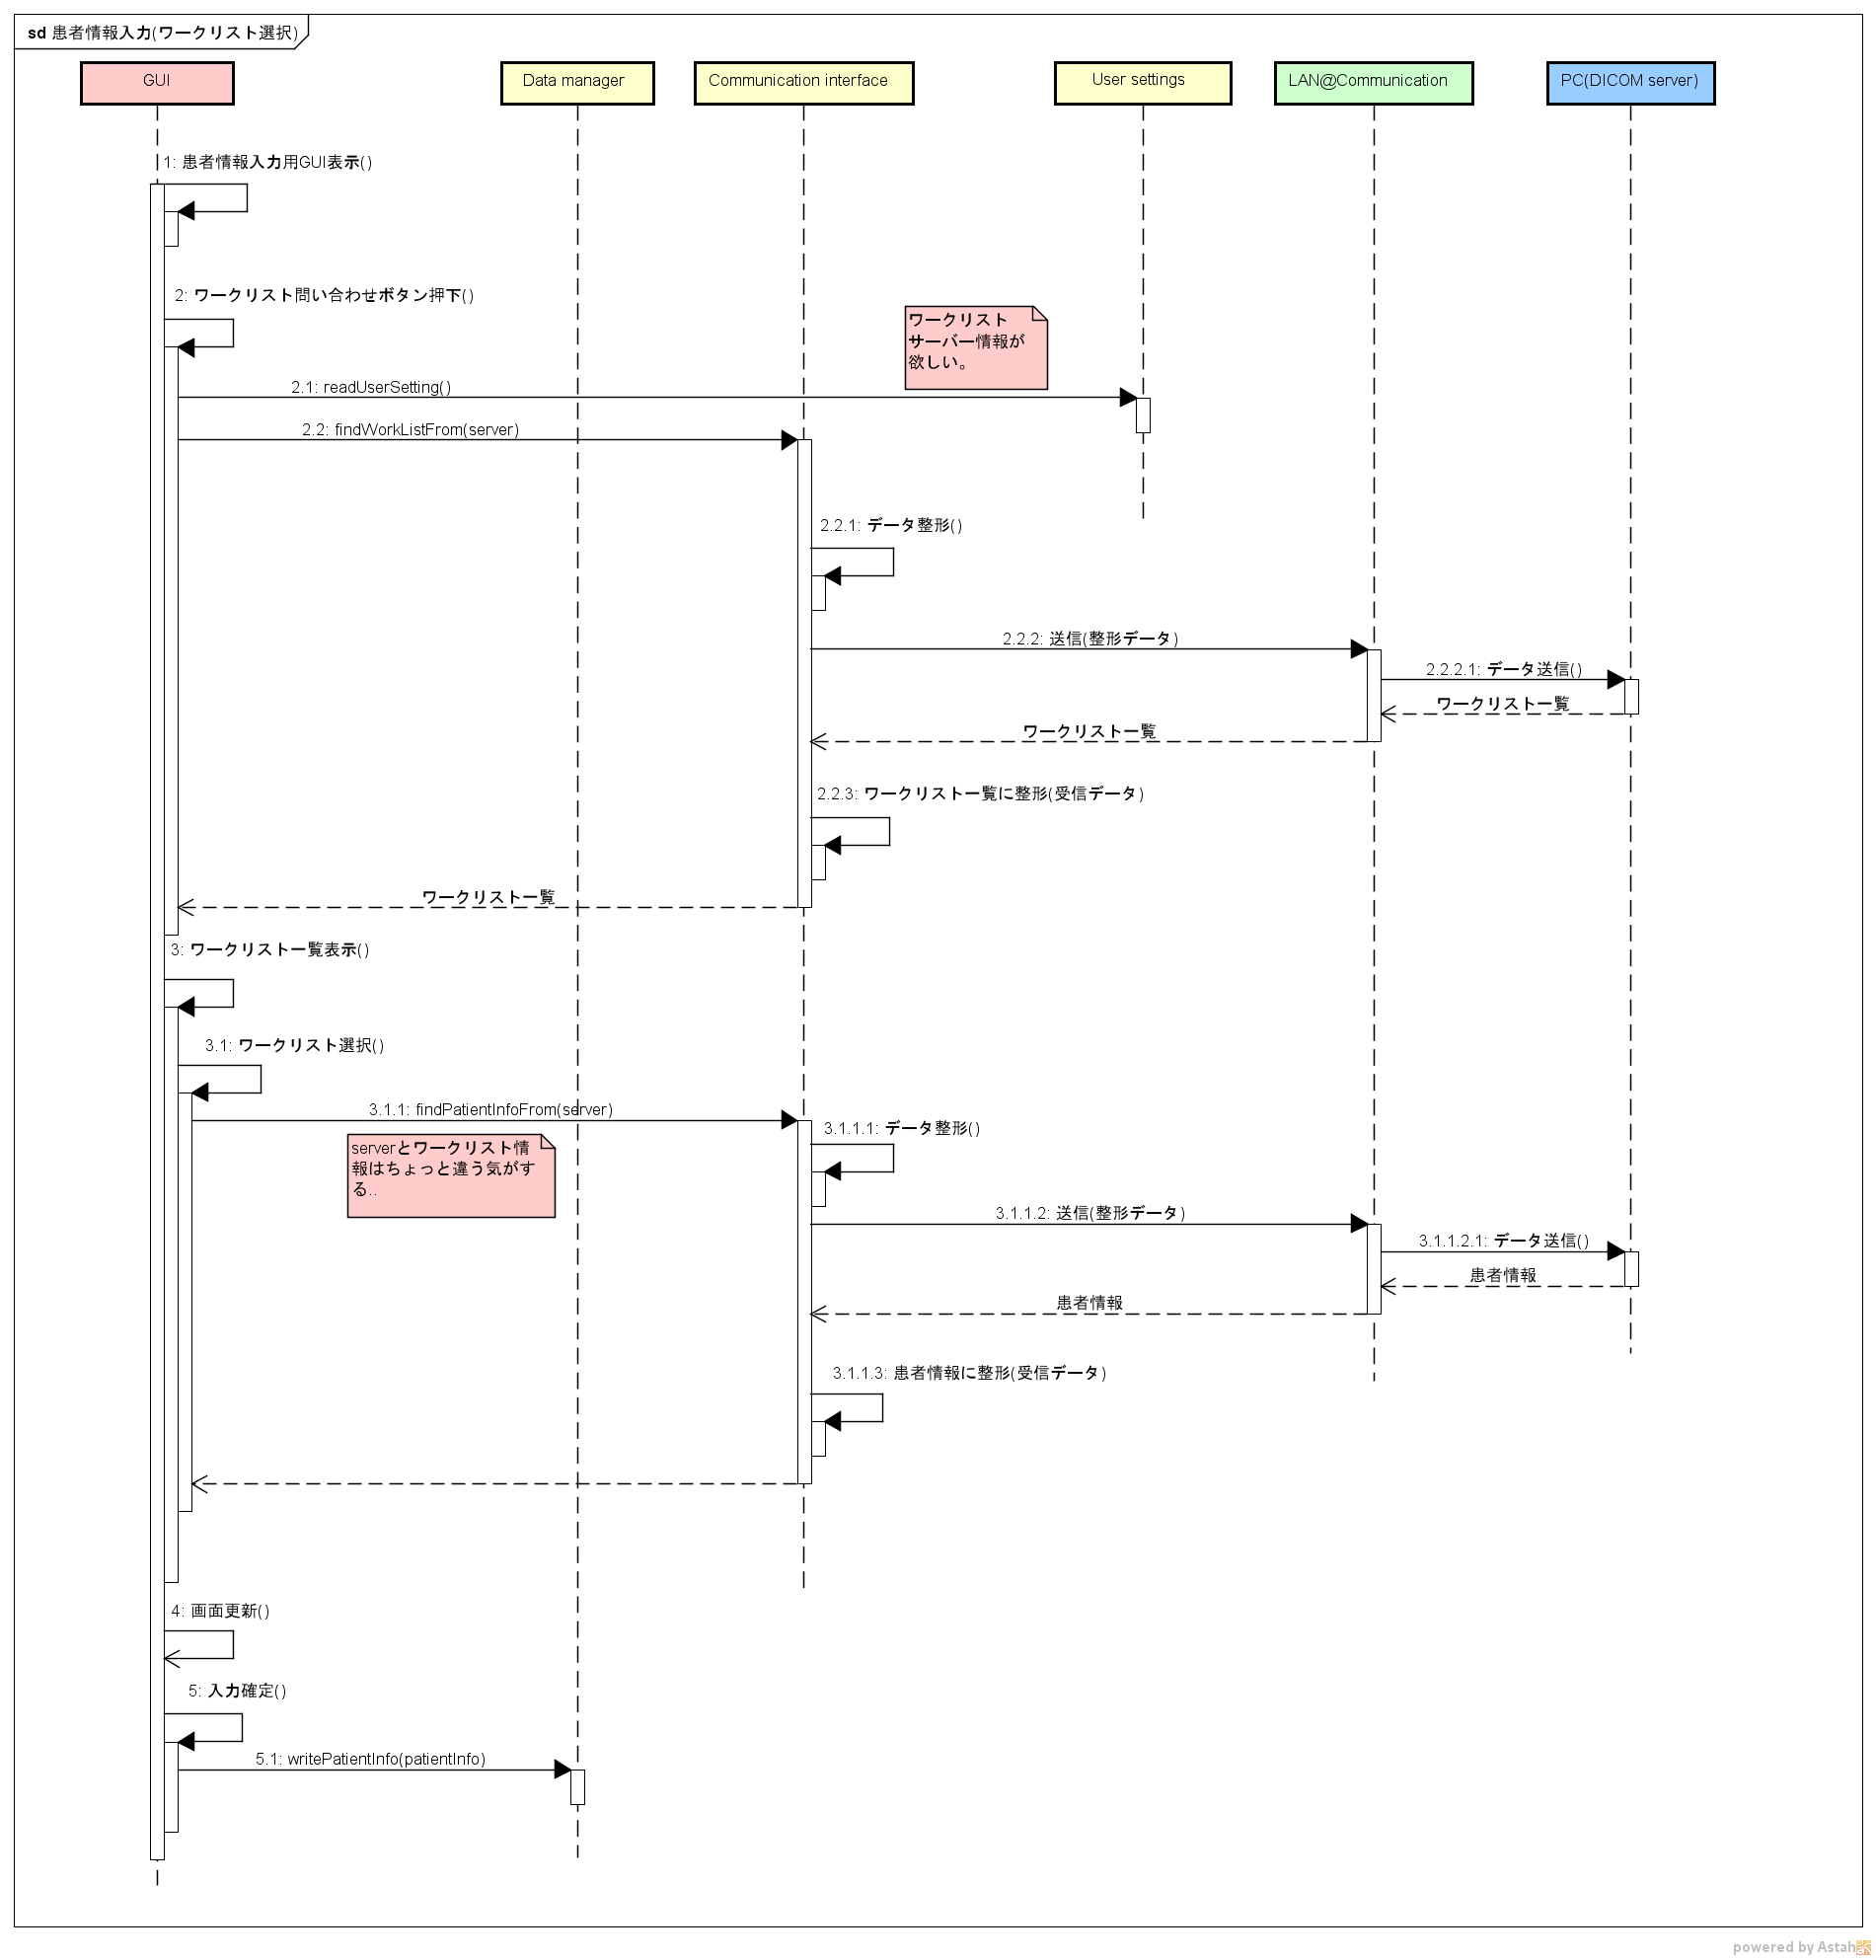

Shaping patient information (Receive data)

Patient information

Send data ( )

Patient information

Send (shaped data)

Fixed input ( )

Update screen ( )

Data shaping ( )

It seems work list information  
 is bit different than server

Select work list ( )

Display work list ( )

List down work list

List down work list

Shaping work list (Receive data)

List down work list

Send data ( )

Send (Shaped data)

Data shaping ( )

Work list server information  
is not matching.

Click work list query button ( )

GUI Display for patient information input ( )

sd Input patient information (work list selection)

Figure ‑ Input of patient information (work list selection)

### Measurement

#### Refractometer measurement

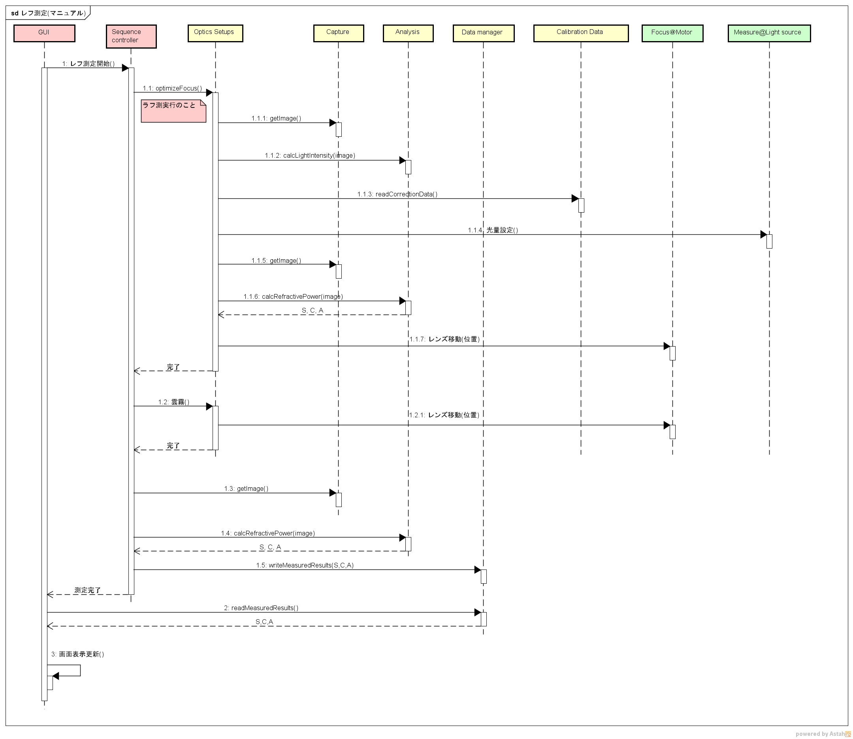

Measurement   
complete

Update screen display ( )

Cloud and fog ( )

Completion

Completion

Lens movement (Position)

Lens movement (Position)

Set light intensity ( )

Measure

reflection

Start measuring reflection ( )

sd Measure reflection (Manual)

Figure ‑ Refractometer measurement

#### Keratotometer measurement

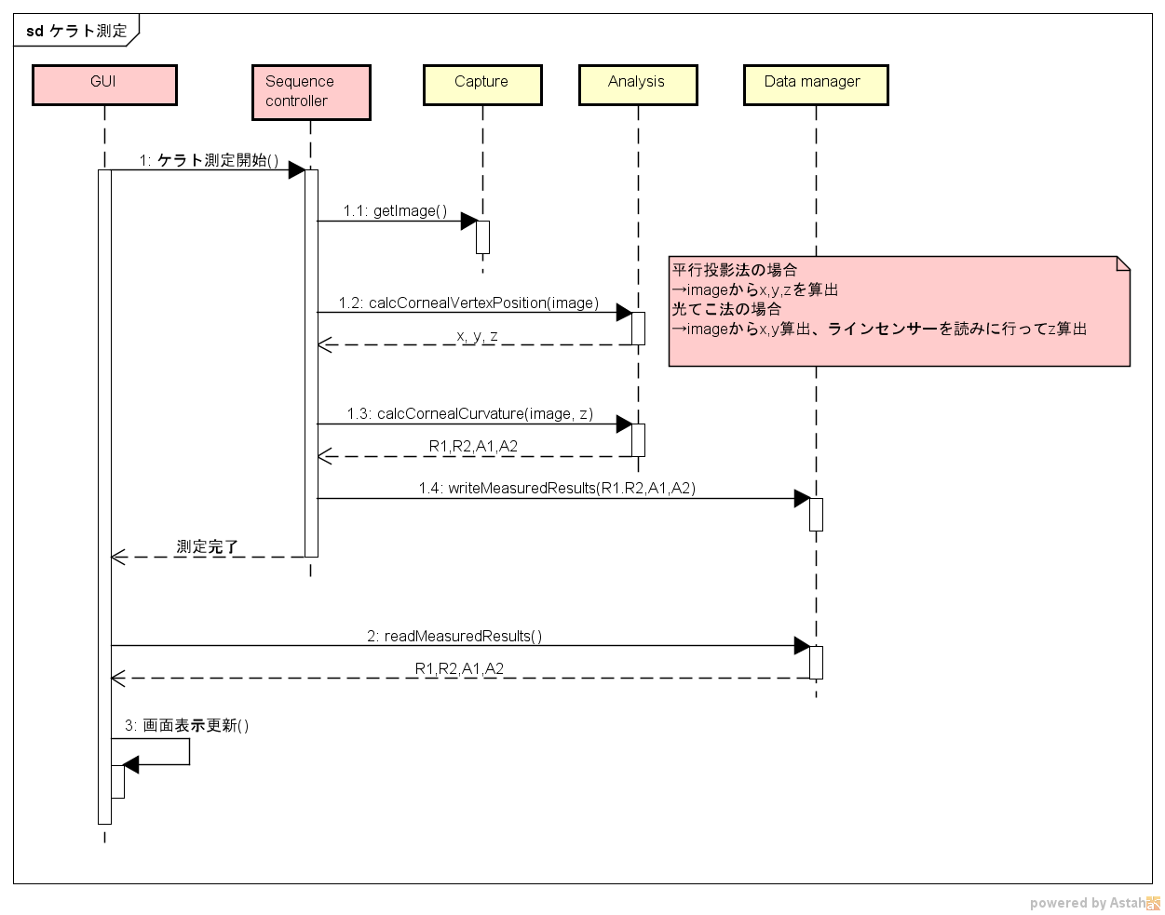

In case of Parallel projection,

Calculate x,y,z from image  
In case of optical lever,

Calculate x,y from image and calculate z by reading line sensor

sd Measure kerato

Update screen display ( )

Measurement complete

Start measuring Kerato ( )

Figure ‑Keratometer measurement

#### Intraocular pressure measurement

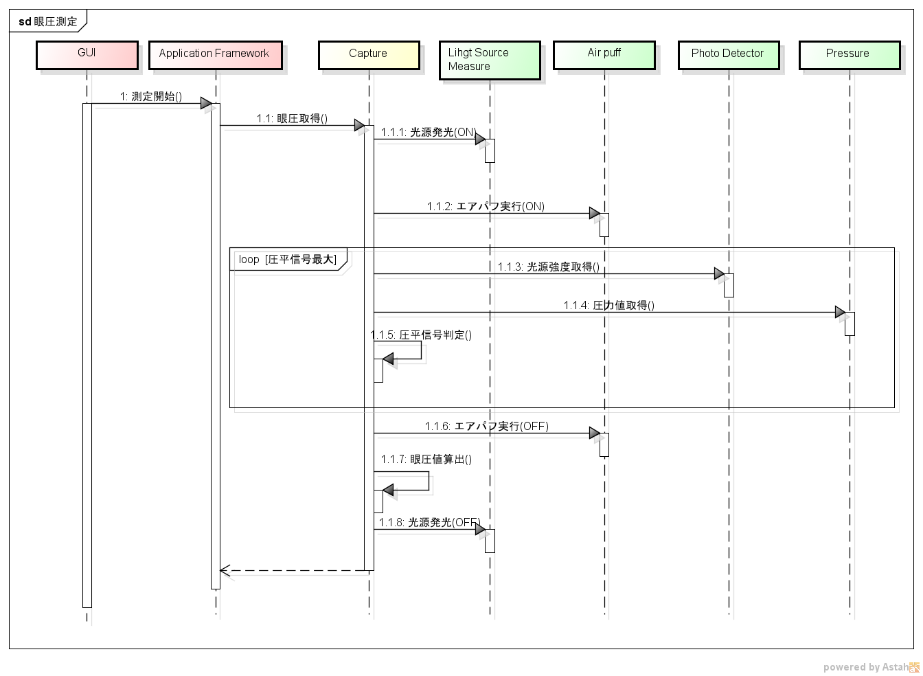

Light emission (OFF)

Acquire applanation value ( )

Acquire light emission intensity ( )

Calculate ocular pressure value ( )

Determine applanation signal ( )

Execute ear power (OFF)

Loop [applanation signal  
 maximum value]

Execute ear power (ON)

Light emission (ON)

Acquire ocular pressure ( )

Start measurement ( )

Sd ocular pressure measurement

Figure ‑Intraocular pressure measurement

#### Cornea thickness measurement

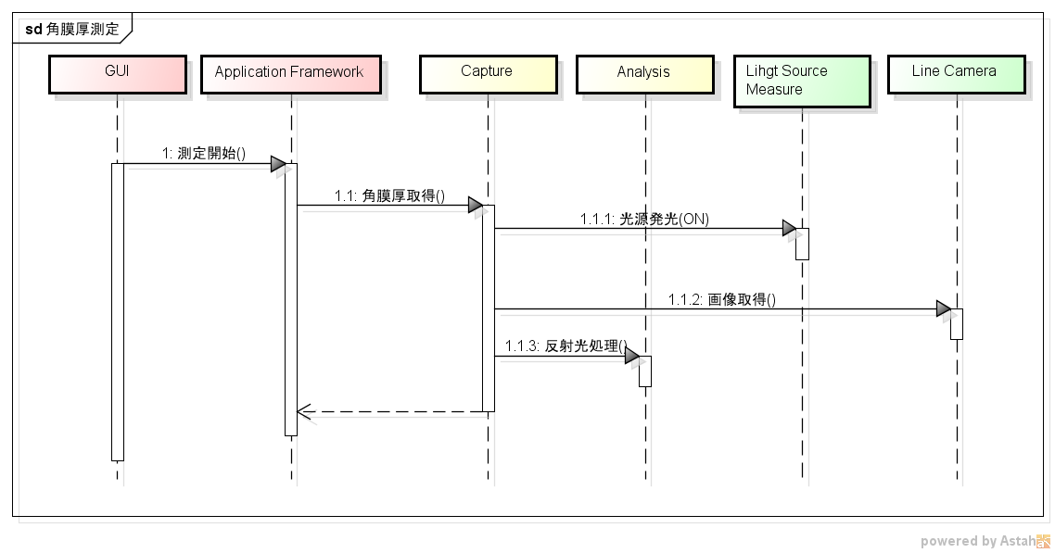

Reflected light processing ( )

Acquire image ( )

Light emission (ON)

Acquire cornel thickness ( )

Start measurement ( )

sd Corneal thickness measurement

Figure ‑ Cornea thickness measurement

#### OCT photography

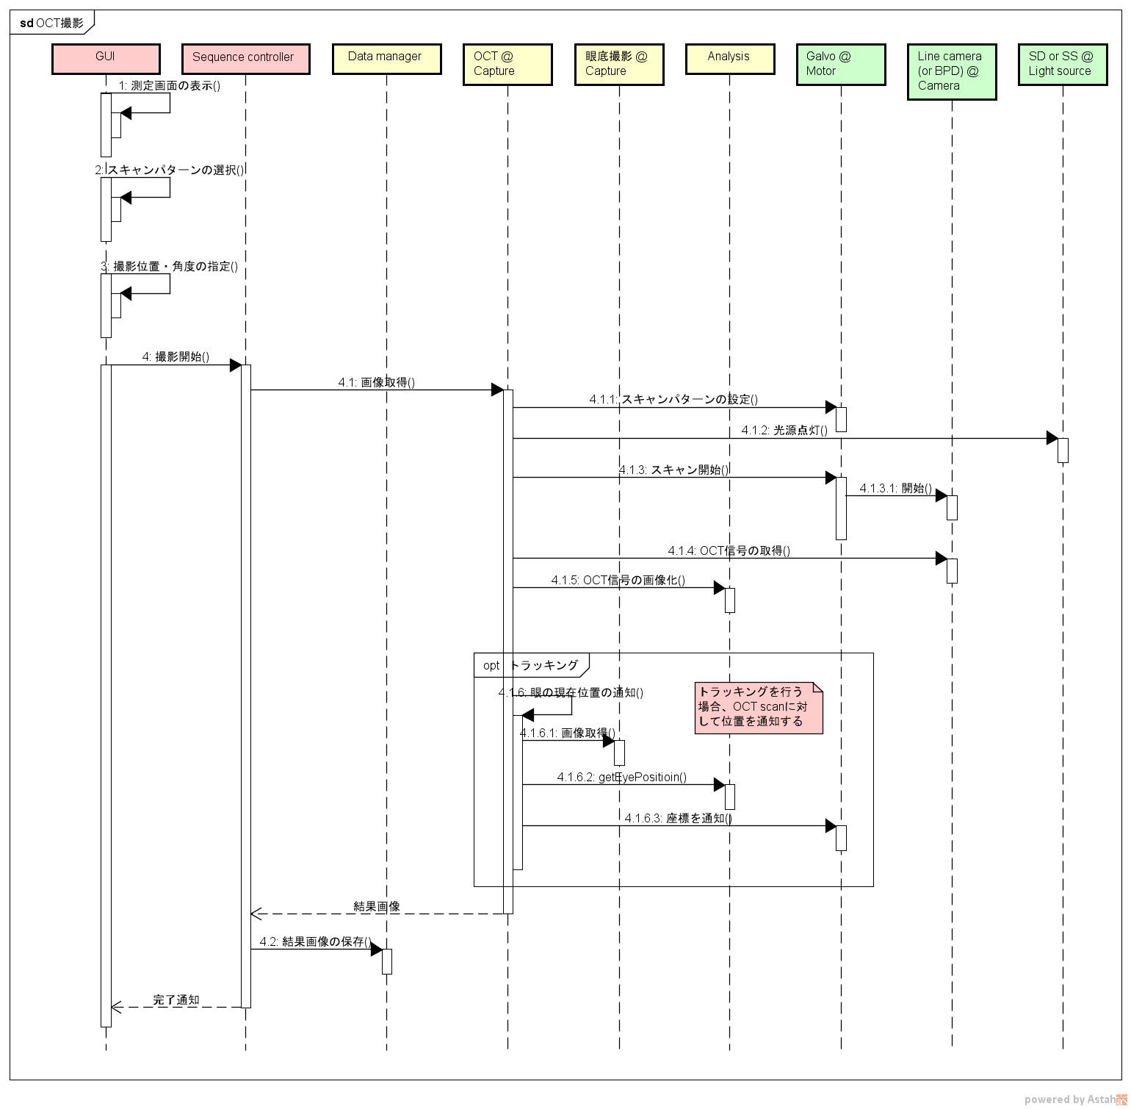**Figure 9‑11 OCT photography**

When tracking, notify the position

For OCT Scan.

Notify coordinate

Complete notification

Save result image ( )

Image result

Acquire image ( )

Notify current position of eye ( )

Opt tracking

Imaging of OCT signal ( )

Acquire OCT signal ( )

Start scanning ( )

Start ( )

Light up illuminant ( )

Setting scan pattern ( )

Acquire image ( )

Start imaging ( )

Imaging position/Specification of angle ( )

Select scan pattern ( )

Display measurement screen ( )

Sd OCT imaging

#### Chin rest adjustment

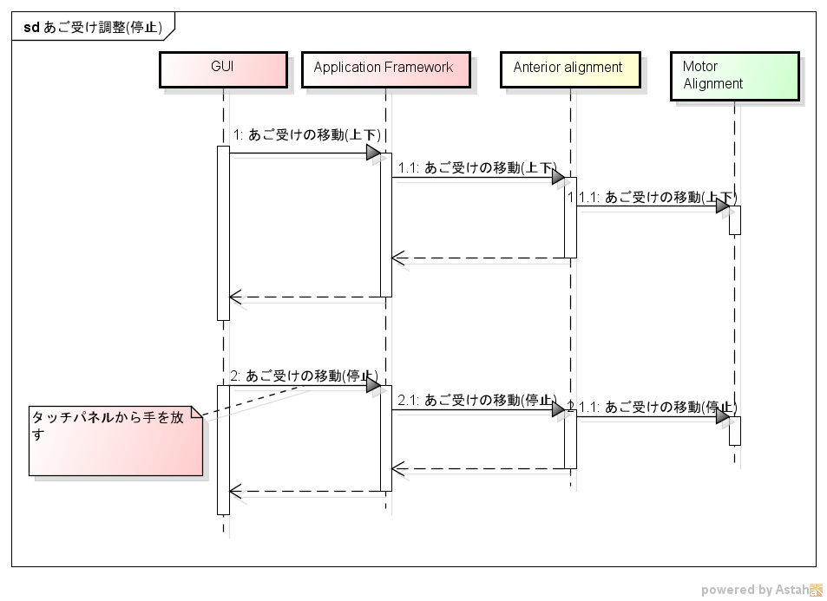

Release hand from touch panel

Movement of chin rest (stop)

Movement of chin rest (stop)

Movement of chin rest (stop)

Movement of chin rest (Up/down)

Movement of chin rest (Up/down)

Movement of chin rest (Up/down)

Sd chin rest adjustment (Stop)

Figure ‑ Chinrest adjustment

#### Auto alignment

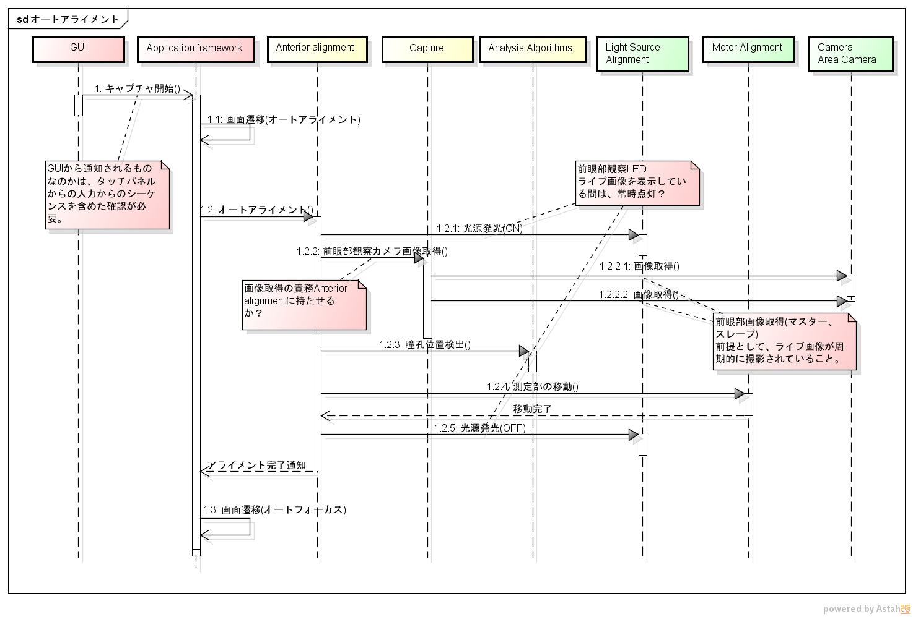 Figure ‑ Auto alignment

When acquiring anterior eye part image (master, slave) it is assumed that live image captured periodically.

Detect pupil position ( )

Does the anterior alignment is responsible for acquiring image?

Is the LED lamp always on, while displaying the anterior eye observation image?

Screen movement (Auto-focus)

Light emission (OFF)

Acquire image ( )

Alignment complete notification

Movement complete

Move measurement part ( )

Acquire anterior eye part observation camera image ( )

Acquire image ( )

Light emission (ON)

It is necessary to check whether the notification is from the GUI, including the sequence from the input from the touch panel.

Auto alignment ( )

Movement of screen (Auto alignment)

Start Capturing ( )

Sd auto alignment

#### Fundus oculi photography

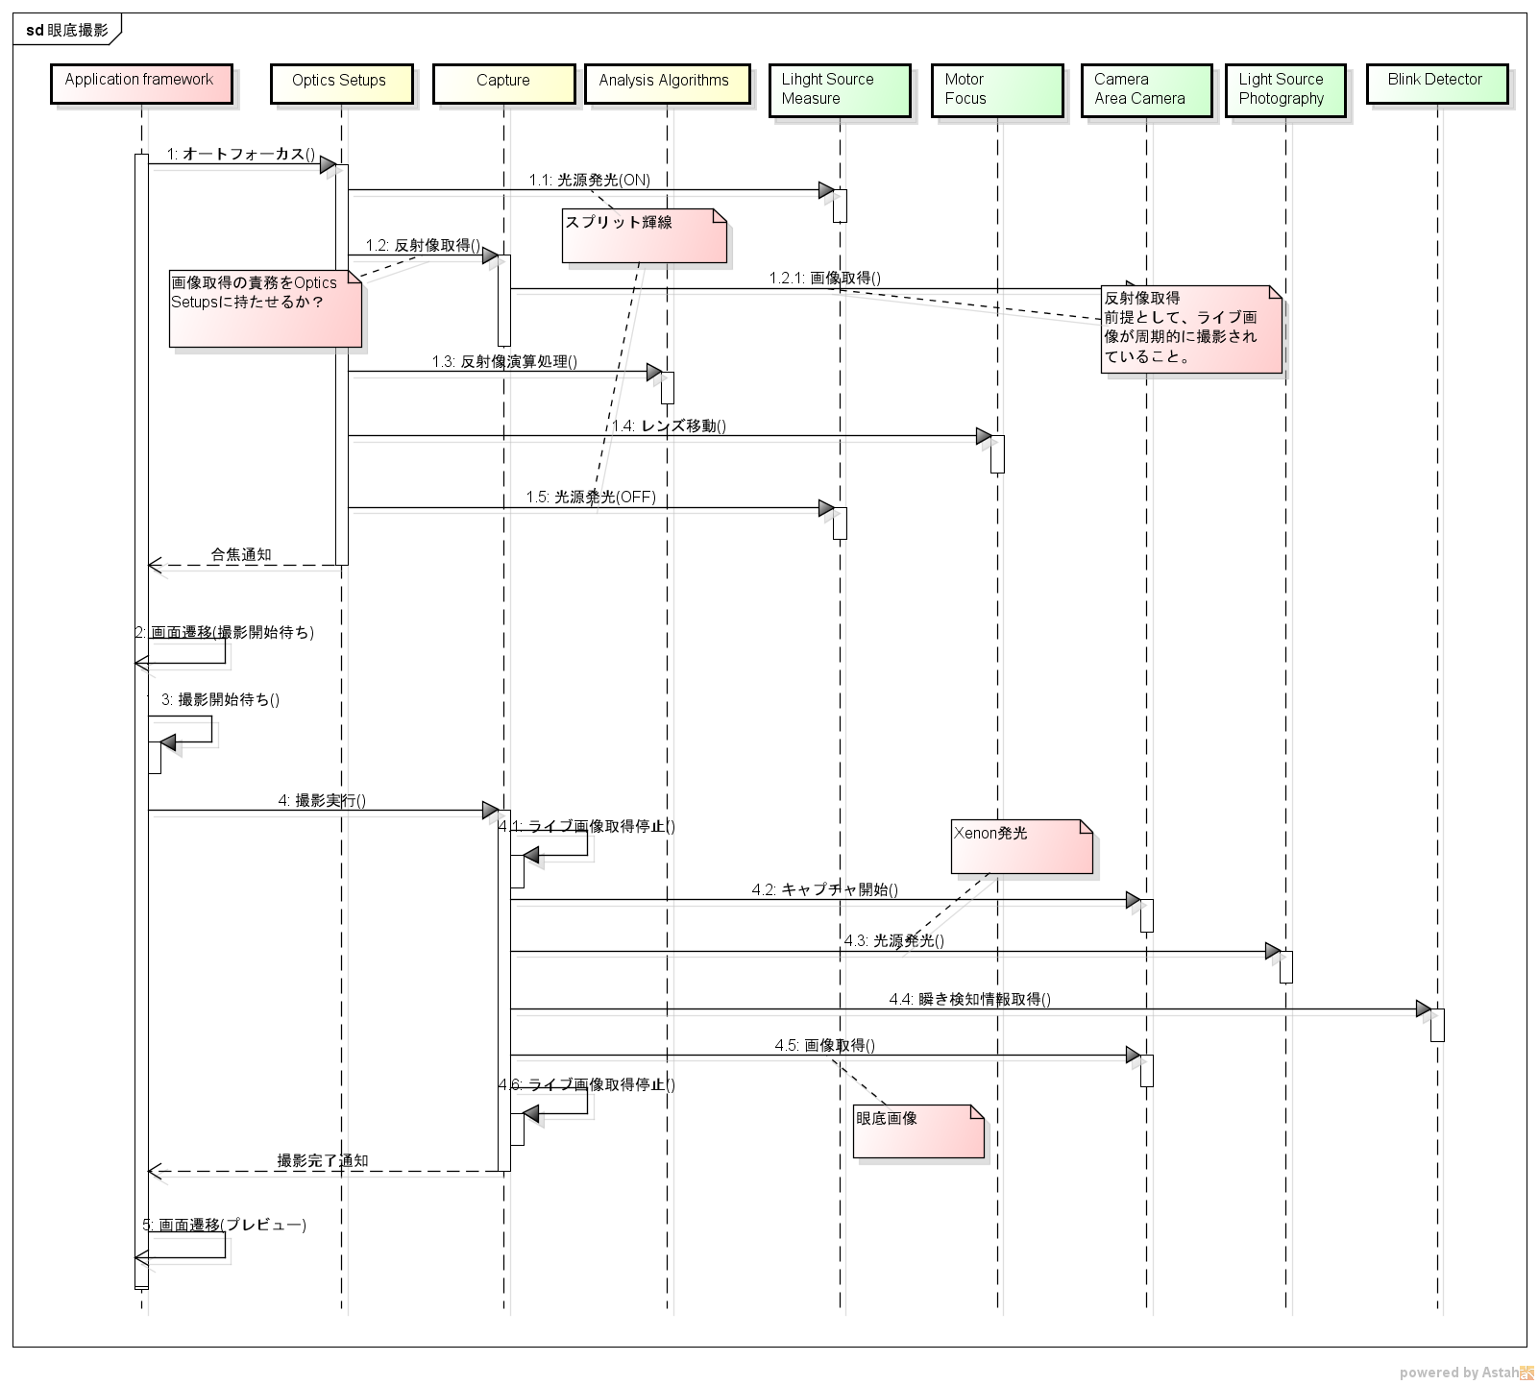

Acquire instant detection of information ( )

Imaging completion notification

Screen movement (Preview)

Stop acquiring lamp image ( )

Stop acquiring lamp image ( )

Fundus image

Light emission ( )

Xenon emission

Acquire image ( )

Screen movement (Waiting to start imaging)

Waiting to start imaging ( )

Implement imaging ( )

Start capturing ( )

Focus notification

When acquiring reflection image, it is assumed that live image is captured periodically.

Reflected image operational treatment

Lens movement ( )

Light emission (OFF)

Is the responsibility of acquiring image is given to optics setups?

Split emission line

Acquire reflected  
 image ( )

Acquire image ( )

Light emission (ON)

Auto focus ( )

Sd fundus imaging

Figure ‑ Fundus oculi photography

#### Display of photographic image

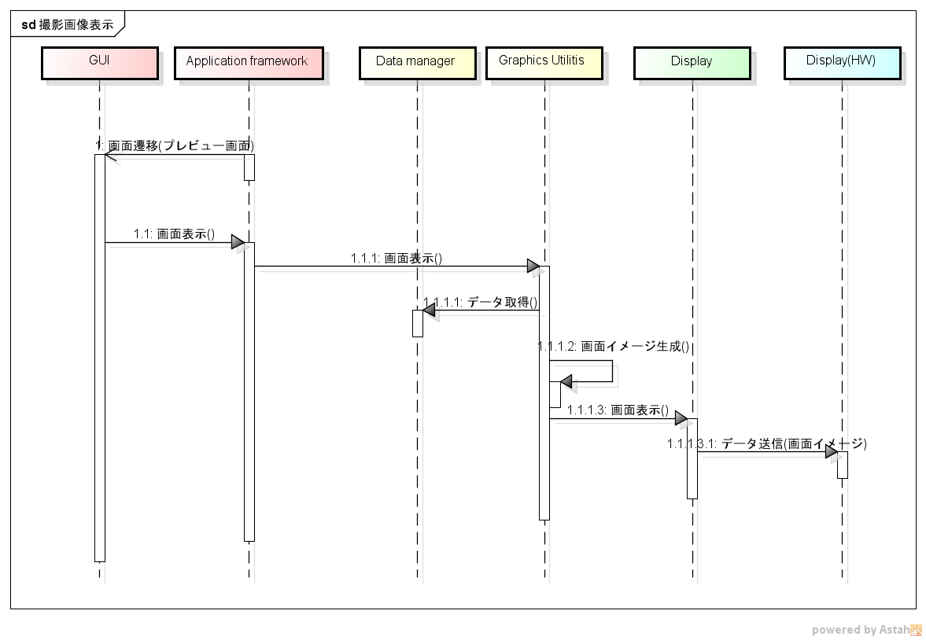

Send data (Screen image)

Display screen ()

Generate screen image ( )

Acquire data ( )

Display screen ( )

Display screen ( )

Screen movement (Preview screen)

sd Display scanned image

Figure ‑ Display of photographic image

#### Saving of photograpic image

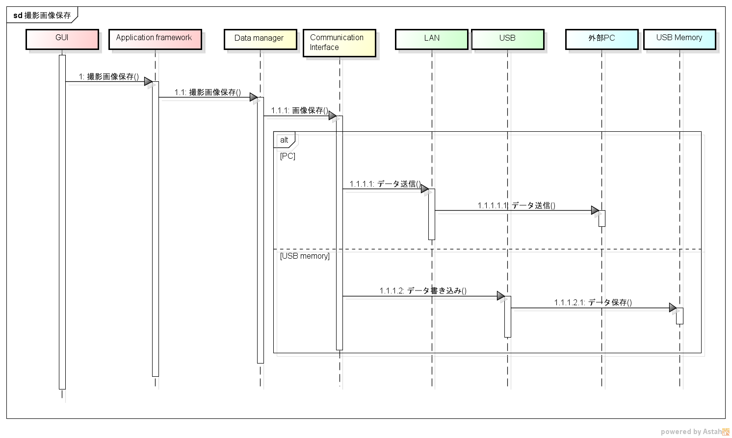

Save data ( )

Write data ( )

Send data ( )

Send data ( )

Save image ( )

Save scanned image ( )

Save scanned image ( )

Sd Save scanned image

Figure ‑ Saving of photographic image

#### SP

TBD

### External output

#### Print

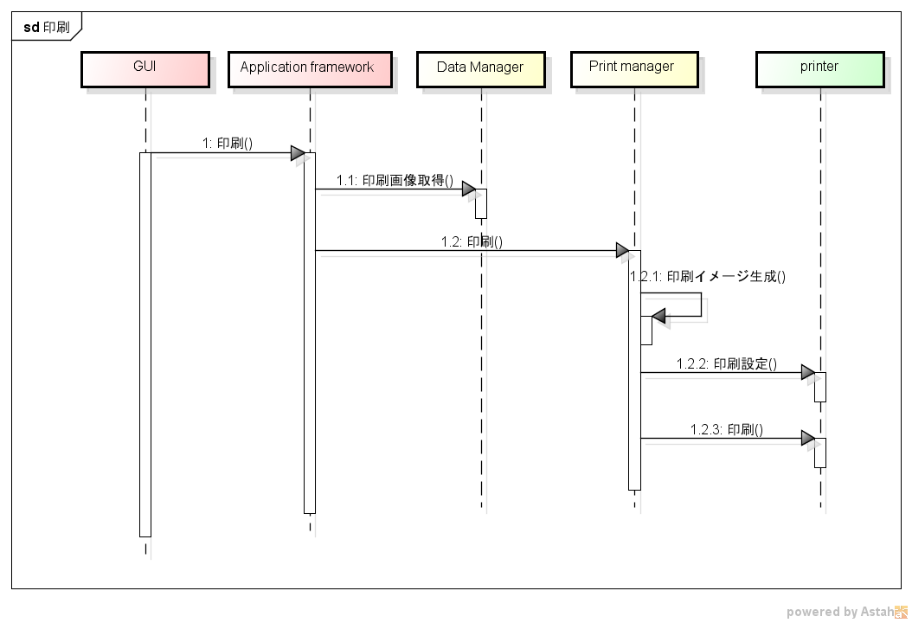

Print ( )

Print setting ( )

Generate print image ( )

Print ( )

Acquire print image ( )

Print ( )

Sd Print

Figure ‑ Print

#### Data transfer

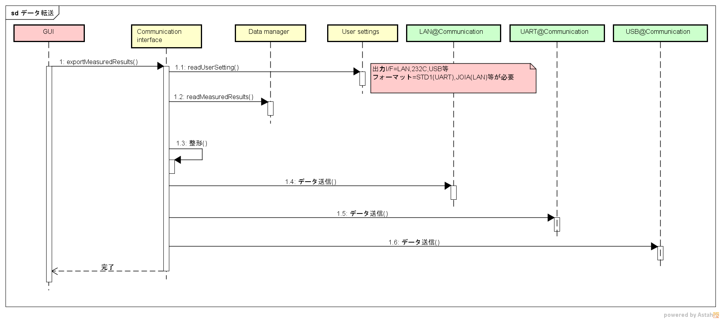

Output I/F= LAN, 232 C, USB format=STD1 (UART), JOIA (LAN) are required.

Sd Data transfer

Send data ( )

Shaping ( )

Send data ( )

Completion

Send data ( )

Figure ‑Data transfer

### Miscellaneous

#### Display of live image

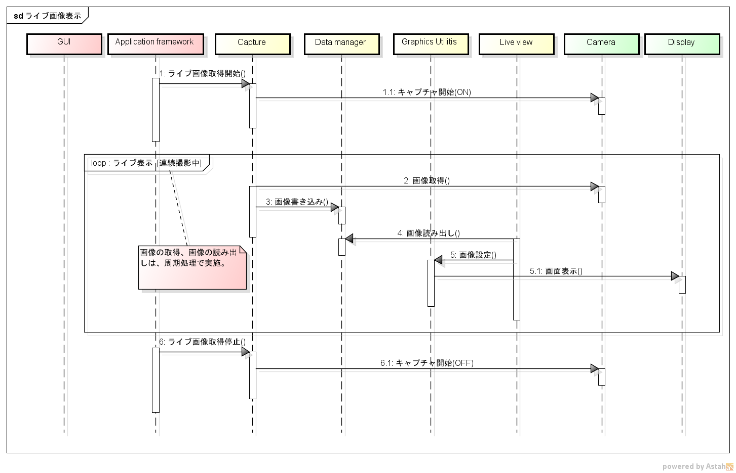

Implement image acquisition, image reading as a periodical process.

Stop acquiring live image ( )

Live display [During continuous imaging]

Start capturing (OFF)

Display image ( )

Image settings ( )

Read image ( )

Write image ( )

Acquire image ( )

Start capturing (ON)

Start acquiring live image ( )

Sd Display live image

Figure ‑ Display of live image

#### Touch input

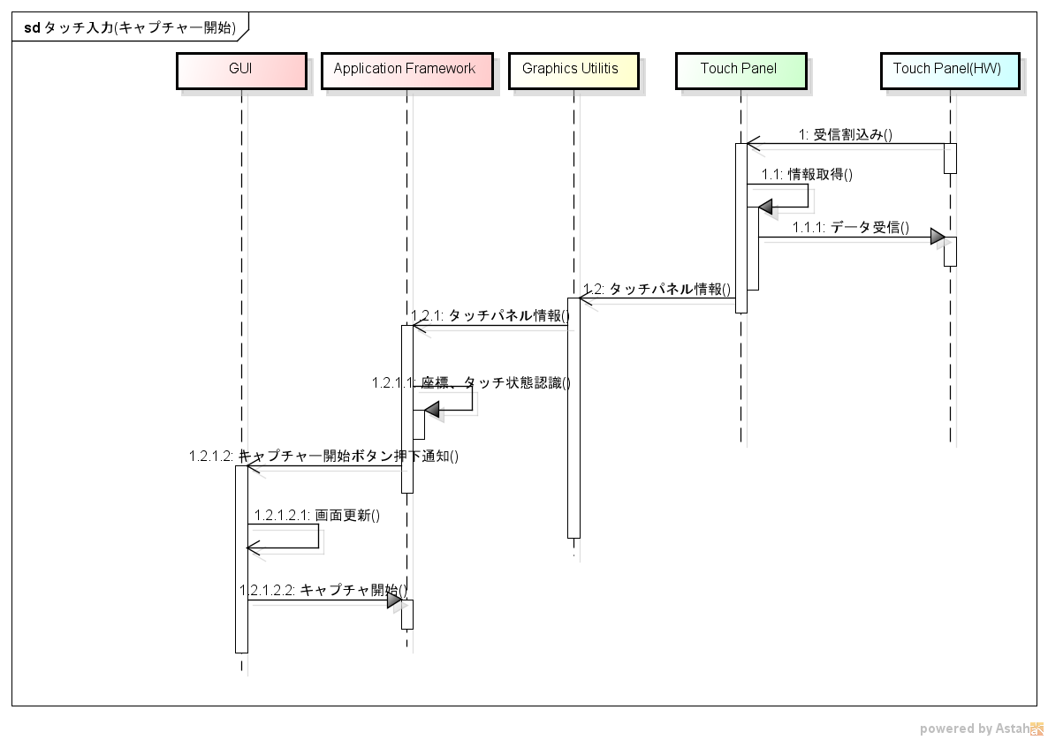

Understand coordinate, touch status

Start capturing ( )

Update screen ( )

Notification for click start capturing button ()

Touch panel information ( )

Touch panel information ( )

Receive data ( )

Acquire information ( )

Receive interruption ( )

Sd Touch input (Start capturing)

Figure ‑Touch input

End of file